**Recombinant Corticotropin-releasing factor receptor 2 (CRHR2)**

**Catalog No.：TP10442 100µg**

**Sequence Information**

**Species：**Human **Gene ID:1395**

**Swiss Prot:**Q13324 **Synonyms:**CRFR2

**Residues:**Glu20-Lys108

EELLLDGWGPPLDPEGPYSYCNTTLDQIGTCWPRSAAGALVERPCPEYFNGVKYNTTRNAYRECLENGTWASKINYSQCEPILDDKQRK

**Product Information**

**Source:** Recombinant expression.

**Host:** *E.coli*

**Tags:** N-terminal His-Tag

**Subcellular Location:** Cell membrane.

**Purity:** >90%

**Traits:** Freeze-dried powder

**Buffer formulation:** PBS, pH7.4, containing 0.01% SKL, 1mM DTT, 5% Trehalose and

Proclin300.

**Original Concentration:** 200µg/mL

**Applications:** Positive Control; Immunogen; SDS-PAGE; WB.

(May be suitable for use in other assays to be determined by the end user.)

**Predicted [isoelectric point](app:ds:  isoelectric point):** 4.4

**Predicted Molecular Mass:** 13.5kDa

**Accurate Molecular Mass:** 14kDa as determined by SDS-PAGE reducing conditions.

**[ USAGE ]**

Reconstitute in ddH2O to a concentration of 0.1-0.5 mg/mL. Do not vortex. **[ STORAGE AND STABILITY ]**

**Storage:** Avoid repeated freeze/thaw cycles.

Store at 2-8oC for one month.

Aliquot and store at -80oC for 12 months.

**Stability Test:** The thermal stability is described by the loss rate. The loss rate was determined by accelerated thermal degradation test, that is, incubate the protein at 37oC for 48h, and no obvious degradation and precipitation were observed. The loss rate is less than 5% within the expiration date under appropriate storage condition.

**[ IDENTIFICATION ]**

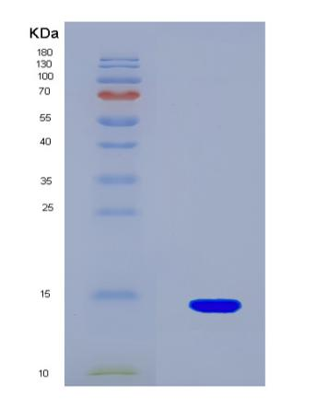

**Figure 1. SDS-PAGE**

**[ IMPORTANT NOTE ]**

The kit is designed for in vitro and research use only, we will not be responsible for any issue if the kit was used in clinical diagnostic or any other procedures.